Code Review 2
Au’rias Holcombe code Review
- You used try/catch on the math buttons to prevent crashing
- Code is easy to read and easy to follow for a beginner
- Button names are descriptive.
- Correctly using TableAdapter
- comments awesome!
- Using a double for population I think isn’t the best but it still works I think I did the same but once I think about now int variable would be best but that’s just my opinion. Doubles are for averages. Ints are for totals and maxs ( Int sumPop = Convert.ToInt64(cityTableAdapter.Sum()); )
- Message formatting you’re missing the commons in highest pop, lowest pop, and average pop ex: MessageBox.Show($"The Population total is: {sumPop:N0}
- N is the formatting 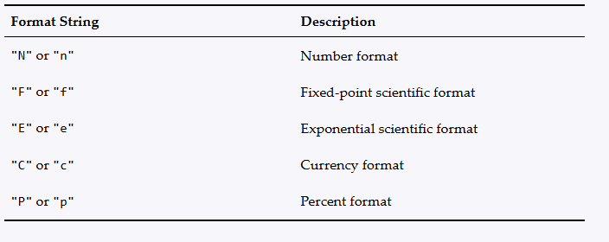
Code reviewed by Eric Maslyanchuk

